Chase Cardinal

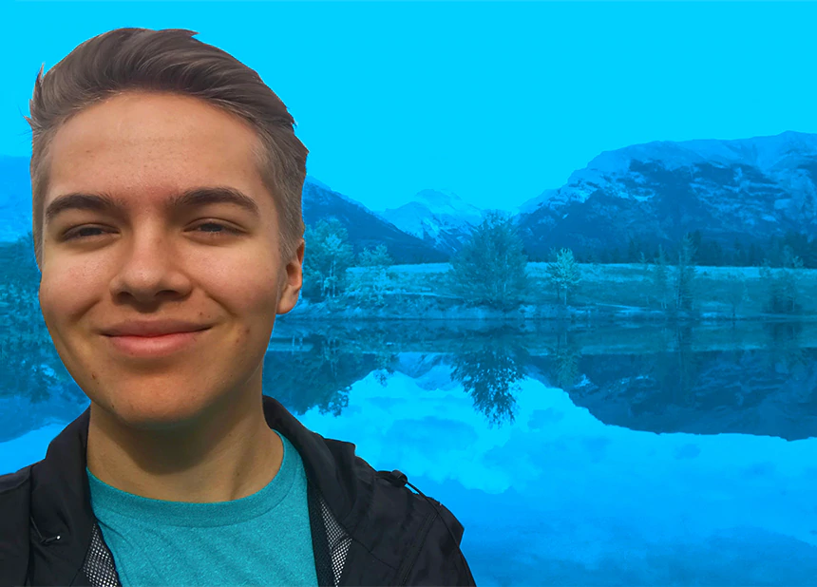
Chase Is a 19 year old climate activist from Calgary. What he wants to see change is based on Alberta and how heavily we depend on fossil fuels. He wants Alberta to transition away from fossil fuels and petroleum products and move towards using more renewable energy sources. He states that we need to take action on tasks that are overlooked and not talked about enough, He has said we need to look at the bigger picture and focus more on major changes that need to be done within our world. He makes sure he says though that all the small changes are very important still like eliminating single use plastics but small justers like that are not enough. Since march 2019 Chase has organised Friday for Future strikes in Calgary outside of city hall,in these strikes hundreds of people join Chase to protest about climate change as a part of Grate Thunbergs global movement.

https://www.cbc.ca/kidsnews/post/more-than-greta-canadian-teen-climate-activists-you-should-know
In this news article It talks about all of the canadian climate activists that are working with Greta Thunbergs. This article shows that there are many young people that believe that we can make a difference about climate change and they bring up many points that we can start working on improving right away. These are just a few of the people working together to try to improve climate change there are also many other young activists all around the world all working on issue related to climate change

https://www.thestar.com/calgary/2019/09/26/these-young-calgary-climate-strikers-talk-about-pushing-back-in-the-heart-of-oil-country.html?rf

